YẾT KIÊU PRIMARY SCHOOL |  |  | THE FINAL TERM TEST I  2022 – 2023
Full name:………………………………… |  |  | Grade 5
Class: 5……. |  |  | Time: 40 minutes
Skill  Mark | Listening | Reading and  writing |  | Speaking | Total
I. LISTENING
Task 1. Listen and match. There is one example (0). ( 1piont)
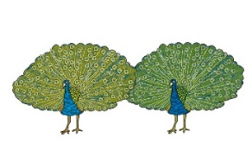 | 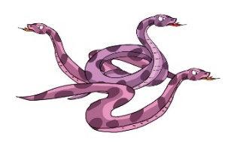 | 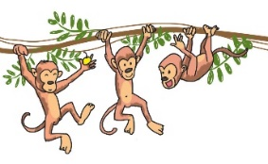 | 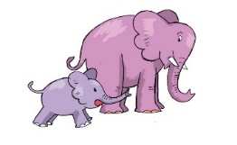
A | B | C | D | E
0 | 1 | 2 | 3 | 4
Task 2. Listen and tick A, B or C. There is one example.( 1piont)
 | I often speak English to my friends. | I read English funny stories. | I write new words and read them aloud.
 | A. | B. | C.
1. | I watch English cartoons on TV. | I write emails to my friends. | I sing English songs.
 | A. | B. | C.
2. | I read English comic books. | I speak English to my friends every day. | I write my diary in English.
 | A. | B. | C.
3. | I read English short stories. | I write emails to my pen friends. | I watch English for Kids on TV.
 | A. | B. | C.
4. | Because I am not good at writing English. | Because I want to write comic books. | Because I want to write to my foreign pen friends.
 | A. | B. | C.
Task 3. Listen and tick the correct pictures. There is one example.( 1piont)
Example: Did he go to Linda’s birthday party?
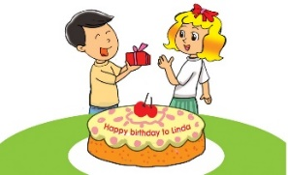 | 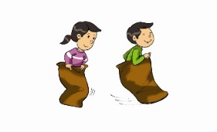 | 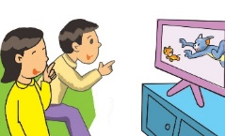
A. | B. | C.
1. When was her last birthday party?
A. | B. | C.

2. What did she do at the party?
A. | B. | C.

3. Did they have a good time there?
A. | B. | C.

4. Did they do anything else at the party?
A. | B. | C.

II. READING AND WRITING
Task 1. Look and write the correct words. There is one example.( 1piont)
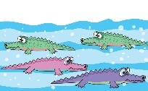 | 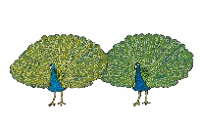 |  | 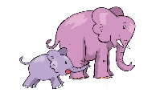 | 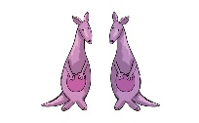
crocodiles | peacocks | white bears | elephants | kangaroos

Example: They live in rivers and eat people and animals in the water. | crocodiles
1. They have two long and two short legs. | _________
2. They live in the Polar regions. | _________
3. They have a long trunk and two tusks. | _________
4. These birds have long and colourful tails. | _________

Task 2. Read and tick () True or False. There is one example (0). (1pt)
 | Vy likes English very much. At school, she has English four times a week. She often speaks English with her classmates. Sometimes, she talks with her foreign friend, Linda. They are happy because they can understand each other. Vy usually reads English comic books in her free time. At home, she practises listening by watching cartoons on TV. Vy wants to learn English well. She thinks English is necessary for her future.
 |  | True | False
0. Vy’s favourite subject is English.
1. She has English every day.
2. Linda can understand Vy’s English.
3. Vy usually reads comic books to practise listening.
4. English is necessary for Vy’s future.

Task 3.Fill each gap with one word from the box. There is one example (0). ( 1piont)
 |  |  |  |  | 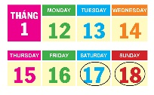
 | birthday | home | present | called | weekend
Dear Grandma,
I’m writing this letter to you because I (0) called you yesterday but you weren’t in. We want to invite you to our (1) ______________ in May. It’s my (2) ______________ on Saturday, 6th of May. I’ll have a big party. Can you and Grandpa come to stay with us that (3) ______________? We’d love to see you.
By the way, the comic book ‘I Want to Be A Star’ is your great (4) ______________ for me.
Thank you so much, Grandma!

Task 4. Look at the pictures. Read and write one word for each gap. ( 1piont)
Example:  He usually plays computer games at the weekend. | 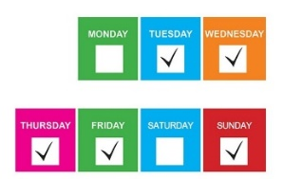

1. | My mother ___________ gets up early in the morning.

2. | He often ___________ a bike to school.

3. | My friends goes to the library ___________ a week.

4. | I often __________ with a partner in class.

Task 5. Order the words. There is one example.( 1piont)
Example: | like / in / I / the / reading / library / books  I like reading books in the library.

1. | you / What / reading / are  ……………………………………………………………………….?

2. | a / I'm / tale / reading / fairy  ……………………………………………………………………….?

3. | the / character / Who / main / is  ……………………………………………………………………….?

4. | character / like / is / main / What / the  ……………………………………………………………………….?

III. Speaking ( 2 points)

--- The end ---

